


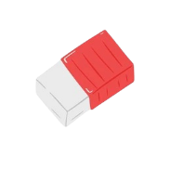



THIS WEEK
ORIENTATION STARTS THIS WEEK!

Free lunches will be held in the school quad. Please make sure you get your food tickets at the door.

Please arrive to class on time as activities start at 9 am sharp!

If you have any questions, you can visit the school office or contact your homeroom teachers.
This semester, our student club and
Student body president are trying to improve the number of clubs and activities held around the school.

Contact Mia Tyler at
mia@gmail.com if you would like to submit a proposal or if you have any further questions.

Watch out for more information in next week’s newsletter

- SEPTEMBER 5: Orientation Begins!
- SEPTEMBER 8: Special P.E
- SEPTEMBER 12: School library reading
- SEPTEMBER 22: Art Show
- SEPTEMBER 25: Photo Day
- SEPTEMBER 27: Science fair contest
PROMOTE YOUR CLUB!
IMPORTANT EVENTS
THE WEEK OF SEPTEMBER 5 – 8, 2026.
WELCOME BACK
STUDENTS!

